Training Top
Ideal for use in the summer during training or as another layer during the colder winter months
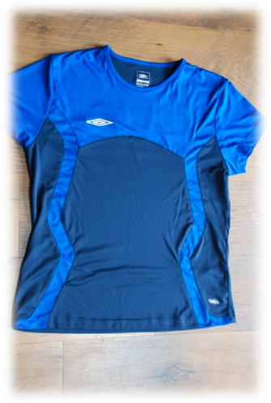
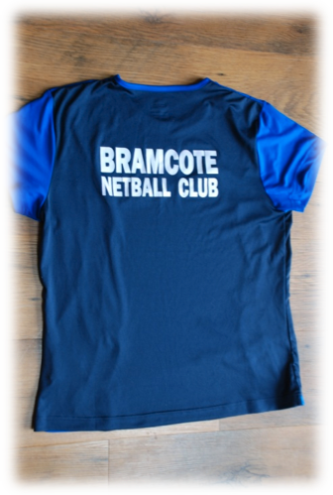

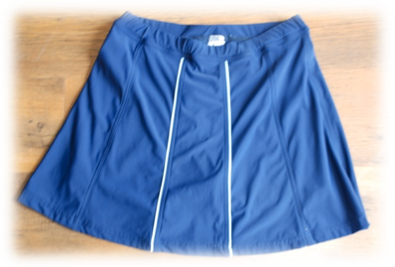
Skorts
A skirt with built in shorts
£22.50 each and comes in sizes 22” – 36” waist
and either 14” or 16” length

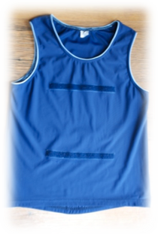
Vest Top
Ideal for playing match games due to velcro patches for bibs.
£12.50 each and comes in sizes S – XXL

Hoodies
Available in Navy or Sky Blue. Embroidery on front with netball logo and players name for individuality. Club name on reverse in screen print.

£15.50 each and comes in sizes XS - XXL

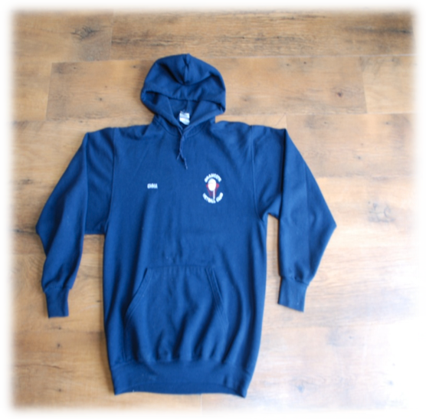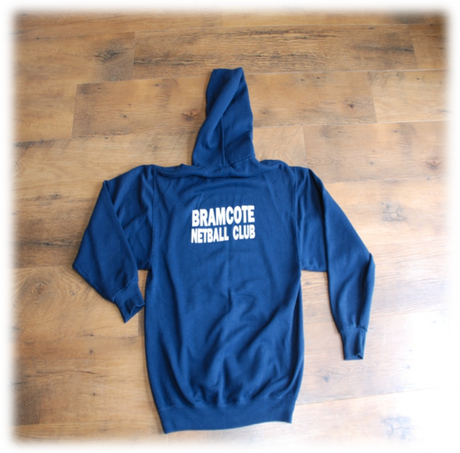

Players Name: _________________________________________________

I wish to order the following new kit:-
(please tick and complete sizes accordingly)

□ Skort Size: Waist _______ X Length ________

□ Vest Top Size: _________

□ Hoodie Size: _________ Colour: ______________________
Name on front: _____________________________________

□ Training Top Size: _________

Total Spends - £

Please note that cheques should be made payable to Bramcote Netball Club at the time of ordering.

